ADDENDUM 1

DATE: May 5, 2020
PROJECT: Dental Lab Services
RFP NO: 744-R2013
OWNER: University of Texas Health Science Center at Houston
TO: Prospective Bidders

This Addendum forms part of and modifies Proposal Documents dated, April 17, 2020, with amendments and additions noted below.

RFP 744-R2013 Dental Lab Services Questions

- Could you share why UT Health is electing to do another RFP for dental lab services?

The School of Dentistry found that the awarded vendors from the previous RFP were not meeting their standards, and wanted to increase their options with a new bid.

- There was a blank on the document for term of the agreement. How long are you expecting the successful bidder to hold prices in place?

We are looking for a 3-year initial term with 2 one-year renewal options.

- The RFP document requested a copy of our financial statement. In the event that we’re not comfortable providing you with our private financial information, could we certify that we are financially sound and have no problems fulfilling our part of the agreement?

We request that all information that is requested be provided in order to insure qualification of the bidding process.

- Could you clarify the items required in response? Several of the items had the word “option” next to them.

The pricing and delivery schedule along with all appendices must be filled out.

- I didn’t see abutments listed in on the pricing sheet. Do you need prices for abutments? If so, could you give detail as to what brands and specific products you need pricing for.

Custom abutments, we use original parts from each implant company:
Zimmer-BellaTek
Nobel- Nobel Procera
Dentsply Astra- Atlantis
Straumann- Straumann CARES
Biohorizons-Vulcan custom dental

- What is the proper method to submit the RFP 744-R2013 Dental Lab Services bid?

At the moment we are looking for hard copies. That may change to electronic submission via email in PDF format due to the COVID-19 situation.

- HUB Subcontracting Plan
I did not see it in Appendix 3 or as a separate attachment?

Please ignore. There will be no subcontracting in this RFP.

- Section 5.4.6 - Scope of Work
It states “lab must provide magnetic mounting plates”.
UTHC providers typically mount their cast models on these prior to case arrival in the lab.
Please advise.
Usually the cases coming from UT will be mounted prior submitting to the lab, except in cases where the student used a triple tray.

- Pricing and Delivery Schedule
Is this only for “Crown and Bridge” Restorations? No partials or dentures?
The pricing and delivery schedule should also include partials and dentures in each step, ie: framework, record bases, teeth set-up, process and finishing.
D2543 – Onlay Metallic. Could you please specify type of metal?
Gold type III
D2750, D2790, D2792: high noble gold for yellow alloy and white alloy
Is there a “Per DWT (pennyweight)” line item? See footnote below.
The list presented is a guide for procurement, so they can compare you on that criteria. It is not intended to be a complete list of all the work that you can perform.
*Some crowns are larger (ie molars) that weigh more and contain more gold. Or require more gold if provider requests metal occlusal for PFMs? Please include an approximate of 2 DWT per crown, to make it standard.
Please advise.
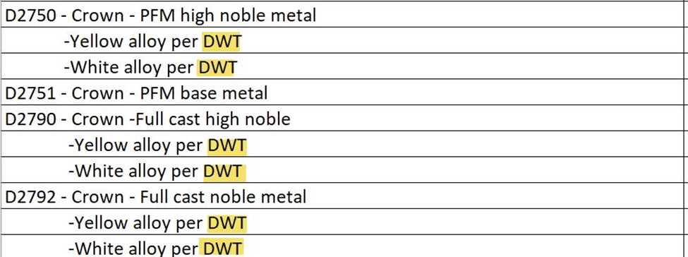
Correct, each crown depending on size will be require different amount of DWT, also if there will require metal occlusals. Usually each 2 DWT per crown.

- Under the Pricing and Delivery section, there's not a column separating anteriors from posteriors so should I just split the difference in the fees?
Yes

- What does the acronym FPD mean? Also, the metal fees depend on the weight of the metal. Should I just figure an average and include it in the fees for the crown?
FPD stands for Fixed Partial Denture. In the table provided above, you can include the fees per different metal, as of today. We know it changes daily.

- Is it necessary to offer a prompt payment discount and, if so, what is the appropriate amount and percentage?

It is not necessary but it is preferred. That can be a topic of negotiation during contracting phase.

- Is there a specific format we need to send this file to you?

We ask that the format be as close to the order of the RFP document as possible. We are requesting hard copies at the moment but that may change to via email in PDF format due to the COVID-19 situation.

- What about forms that need a signature? Do we fax them to you?

Those forms need to be included in the RFP packet or file.

- On the D6548 were it says retainer porcelain for resin bonded, we just want to verify the material so we can price this correctly.
D6545 is retainer metal – base metal
D6548 is retainer porcelain - zirconia

- Is the excel spread sheet 1 through 61 is all that needs to be filled out and submitted for dental laboratories?

The pricing and delivery schedule along with all appendices must be filled out.

- And where we can find the correct way to submit? Can it be emailed, faxed or we need to have someone physically hand it to you.

Please see question 13 for answer.

